Code Enforcement Department – State of the
City 2021

The Code Enforcement Department strives to fairly and efficiently enforce and uphold the Codes and Ordinances while protecting the public health, safety, and welfare of our residents, businesses, owners, and visitors. The City of Wilmington accepts complaints from citizens as well as other local departments and agencies regarding violations of the City’s Property Maintenance and Zoning Codes. The department then investigates each complaint and determines a course of action.
Cases and Violations
The number of new violations increased this year from 433 to 592. Those 592 violations resulted in 263 new cases being opened with some cases consisting of multiple violations at one address. Of the new 263 cases for 2021, 40 cases remain open with an additional 25 cases open from prior years. The chart below shows a breakdown of all current open cases from 2016 to present.

Code Enforcement Case Load
Code Enforcement Cases Opened 2021 | 263
Closed Cases 2021 | 223
Open *New Cases 2021 | 40
Open Cases from 2020 | 14
Open Cases from 2019 | 5
Open Cases from 2018 | 4
Open Cases from 2017 | 1
Open Cases from 2016 | 2
Total Open Cases (As of 12/28/2021) | 66

Of the 263 new cases opened this year, 223 have been resolved and closed. This department has made closure of the oldest open cases a priority. The chart below is a breakdown of the current statuses of the 66 open cases.

Open Case Status
Compliance in Process | 5
Open Court Cases- Municipal | 6
Follow Up Inspections Scheduled-First Notice Sent | 9
Follow Up Inspections Scheduled-Second Notice Sent | 3
Follow Up Inspections Scheduled-Final Notice Sent | 7
In Foreclosure- Compliant | 2
Noncompliant- Submitted to City Prosecutor | 8
Noncompliant- Submitted to County Prosecutor (delinquent property taxes) | 5
Land Bank Owned- Pending Demolition or Rehab | 4
Various stages of monitoring and compliance | 17

Violations of the zoning and property maintenance codes are addressed by issuing formal violation notices and working with the property owner and/or tenants to bring their property into compliance within a specified time frame. If property owners are not compliant, the cases are then turned over to the City Prosecutor and criminal charges are filed in Municipal Court.

In August of this year, the Code Enforcement Department began working on other strategies for compliance with City Ordinances. For specific violations, the department first issues a general warning, sent by mail or posted at the property, regarding potential violations. This practice has saved time and resources and many of these violation warnings were quickly remedied by the property owner or tenant, without needing to open a formal case. Working closely with the Sanitation, Street, and Wastewater Departments, we have been able to identify potential problems, and then notify citizens about the proper practices of removing trash and recycling containers, obstructions left in the right-of-way, and hazards to the storm drains. This program has had a 95% success rate, with only a handful of violations escalating to open Code Enforcement cases.

Violation Warnings Issued
Trash Containers (Left in street after pick-up time) | 63
Basketball Hoops (Left in street after use) | 23
Trees and Bushes (Obstructing view and right-of-way) | 13
RVs, Boats, and Trailers (Stored on residential streets) | 5
Leaf Pick-Up (Leaves raked into streets and clogging storm sewer) | 14
Total Violation Warnings for 2021 | 118

This department handles a variety of violations regarding exterior property maintenance, junk vehicles, litter, grass and weeds, infestations, interior property issues, and other property issues. Below is a chart of the various violations opened in 2021.

Special Projects
This department had the opportunity to work on a variety of new and challenging projects focused on cleaning up the Wilmington community. Addressing littering, dumping and other blight, while working with other departments, agencies, donors, and volunteers, a lot of progress was made.
City Wide Clean-Up and Beautification Events- Volunteer Projects
April- Southeast Neighborhood Clean-Up | 82 Bags of trash and 200+ Tires
May- Downtown Spring Clean-Up | 20 Bags of trash and 110 Bags of mulch spread
June- Downtown Litter Clean-Up | 15 Bags of trash and weeds
July- Sugar Grove Cemetery Clean-Up | 9 Bags of trash and cleaning of 50+ headstones
August- City Woods Clean-Up | 15 Bags of trash from the Lytle Creek area
Shopping Cart Pick-Up and Removal -Public Nuisances
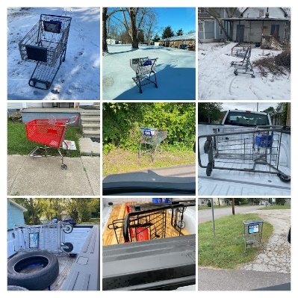
Observing that stolen shopping carts were beginning to be prevalent on our residential streets, the Code Enforcement Department began removing and relocating abandoned shopping carts and notifying each business of the theft. The majority of abandoned cars were located at vacant properties, on sidewalks, and in alley ways. To date 35 carts from various local establishments have been returned, continuing the fight against neighborhood blight.

Collaboration and Community Support
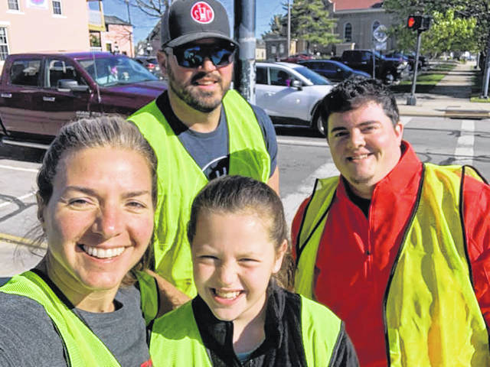
This year the Code Enforcement Department has been privileged to collaborate with several City and County Departments, project donors, and volunteers:
- Clinton County Land Bank (Taylor Stuckert & Ellen Sizer)
- Clinton County Juvenile Court Community Service Program (Chad Mason)
- Clinton County Solid Waste and Recycling District (Jeff Walls & Erin Hartsock)
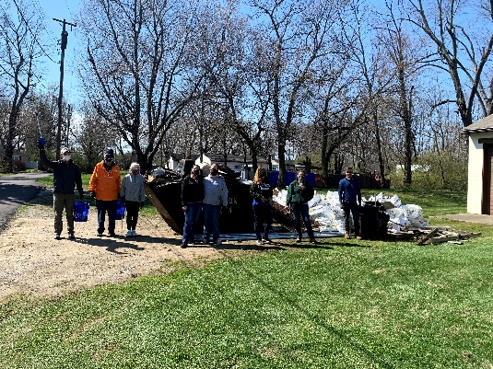
- Clinton County Prosecutor’s Office (Justin Dickman & staff)
- Clinton County Treasure’s Office (Kyle Rudduck & staff)
- City Prosecutor’s Office (David Henry & Jane Horne)
- Clinton County Dog Warden (Rex Doak)
- Wilmington Police & Communications Department
- Wilmington Fire Department
- Wilmington Sanitation Department
- Wilmington Street Department
- Sugartree Landscaping (Lee Sandlin & Crew)
- Main Street Wilmington (Darcy Reynolds)
- State Farm Insurance (Carrie Zeigler)
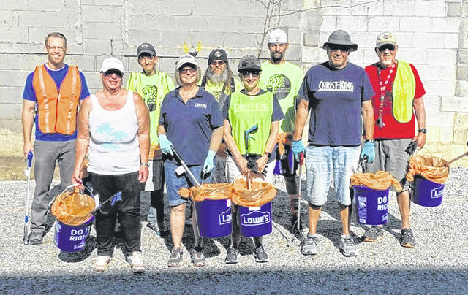
- Caribou Sanitation (Braden Dunham)
- Midnight Auto Repair (Jason Stoops & Leah Lorenz)
- Community Clean-Up Volunteers
Without the support of these departments, agencies, donors, and volunteers, this year’s progress and success would not have been possible.
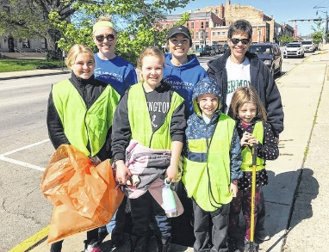
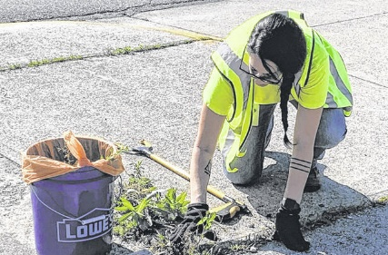

Property Success Stories
Several problem properties were brought into compliance this year, some by property owners and others through hired contractors and abatement.
Mead Street- Garage burned 2/2020 and owner is deceased. Property management company removed the structure 8/2021. House is vacant and case remains open, but compliant.  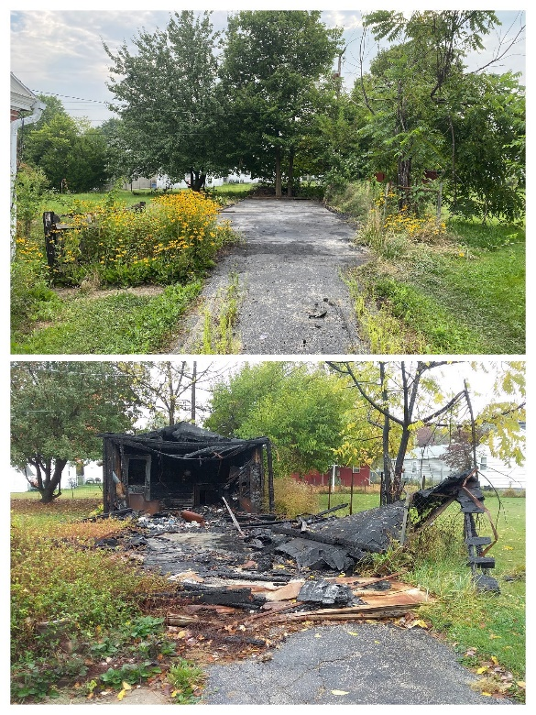 | N. Wall Street- Property has been vacant since 2016. Owner is deceased. Contractors cleaned rear yard, boarded up windows and the city completed the mowing. Submitted to county for back taxes.  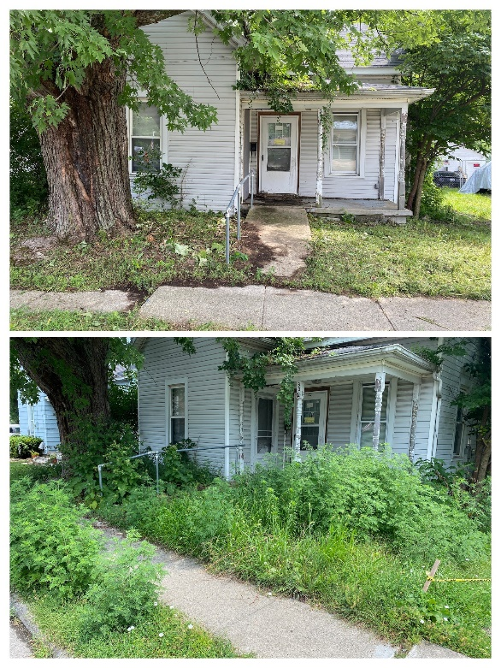
W. Sugartree Street- Complaints from neighbors and tenants about the ongoing issue with the trash containers. Notified the property owner and they quickly addressed the issues.  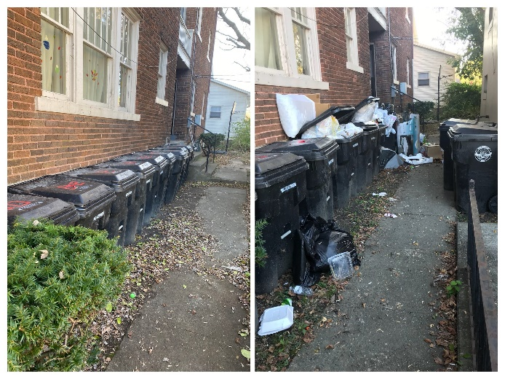 | 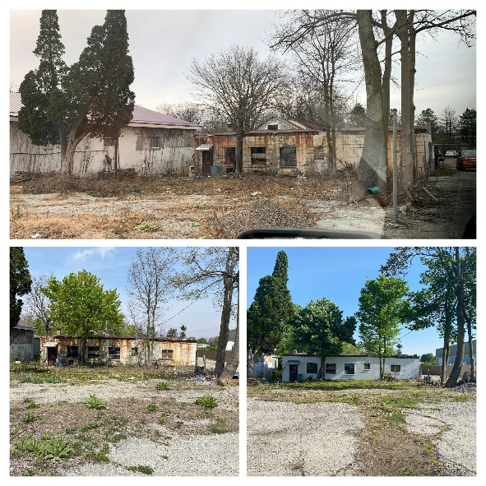  W. Main Street- Worked with owner and tenant for several months to achieve final result and closure of case.

Looking forward to continued success and collaboration in 2021.

Annen Vance,
Code Enforcement Department

