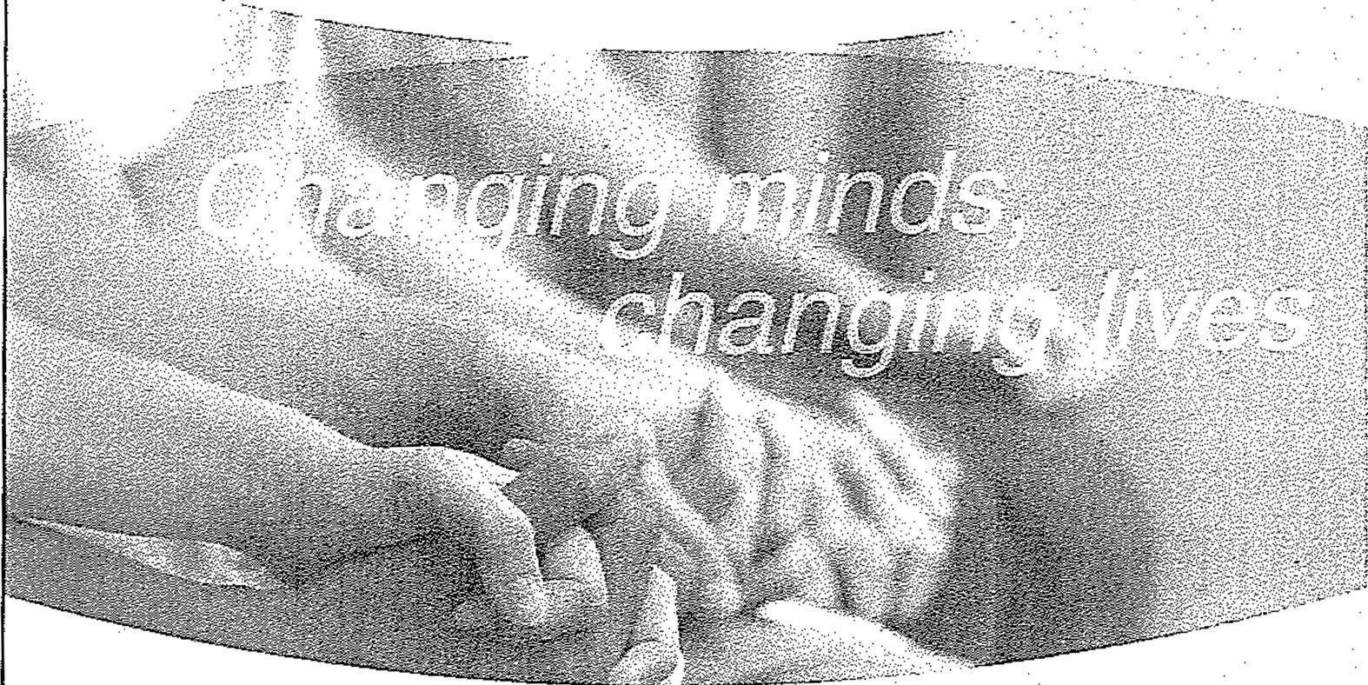
YOU'RE INVITED
- N rf1l
i.J t Jtil=:5-1 ] 1 ;k.J if!
:tr --J;
·i\:;> ;r
:a ·i.-a "
SotrthvvEist Hub PulJHc :Clf fi cial$ Bt'eairfa st ,F1ec { ;Jt i:)rl
Frklmj .1, Nlav 7.., 20:21
8:00 am - 9:30 am

Virtual and accessible from anywhere!
RSVP By Friday, April 30 to Sage Verdi
'?:) 216.325.9673
,3 sverdi@mhaadvocacy.org
@ bit.ly/SouthwestPOR2021
mh c
Mental Health & Addiction
Advoca cy Coalition

mh c
Mental Health & Addiction
Advocacy Coalition Changing minds, changing lives

Missi on
To foster education and awareness of mental health and addiction issues while advocating for public policies and strategies that support effective, well­ funded services, systems and supports for those in need, resulting in stronger Ohio communities.

Membershi p
The MHAC is a state ide membesrhip organization, with Hubs in Northeast and Southwest Ohio, that mobilizes diverse organizations to positiv ely drive change for individuals and famili es needing mental health and addiction services and supports. By identifying opportunities and addressing barriers, the MHAC changes people's lives so they can experience success and a better future , growing stronger and healthier Ohio communities.
Members include: health and human service organizations, the faith-based community, government entities, advocacy organizations, courts, major medical institutions, the corporate arena, and behavioral health agencies serving adults and children.

Southwest Hub
Brown, Butler, Clermont , Clinton, Hamilton, and Warren Counties

Cincinnati: 2600 Victory Parkway Cinc innati, OH 45206 I 513.751.7747 ext. 1718
Cleveland: 4500 Euclid Ave., Cleveland, OH 44103 I 216.432.7262
Columbus: 175 South Third St.. Suite 350, Columbus, OH 43215 I 614.745.0740 ext. 306

mhaadvocacy.org

